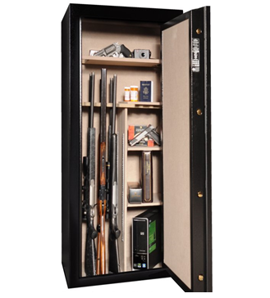
Australian Hunting Net is pleased to announce a new member benefit.
As from date to be included all financial members have cover for their firearms and/or associated equipment whilst in transit, stored in a locked vehicle and/or building in accordance with State Law and if damaged or destroyed whilst in use. Traditionally, the responsibility of this insurance purchase has been left to the individual member but now, should you have no cover in place, the Association will provide cover under your membership [subject to the terms and conditions of the insurance policy].
This insurance is designed to protect each member up to $12,000 with the option to increase this limit to $25,000 for an additional $10 payable by the member. The policy has an excess of $50 each and every claim and protects members anywhere in Australia, 365 days of the year, plus overseas for 21 days in any one year.

Details or inquires can be made to our Insurance Broker, Marsh Advantage Insurance via:
Lauren Coburn Janine Hook
Phone: 08 8385 3616 Phone: 08 8385 3624
Email: lauren.coburn@marshadvantage.com Email: janine.hook@marshadvantage.com

