2018
VICTORIAN HUNTER EDUCATION
COURSE

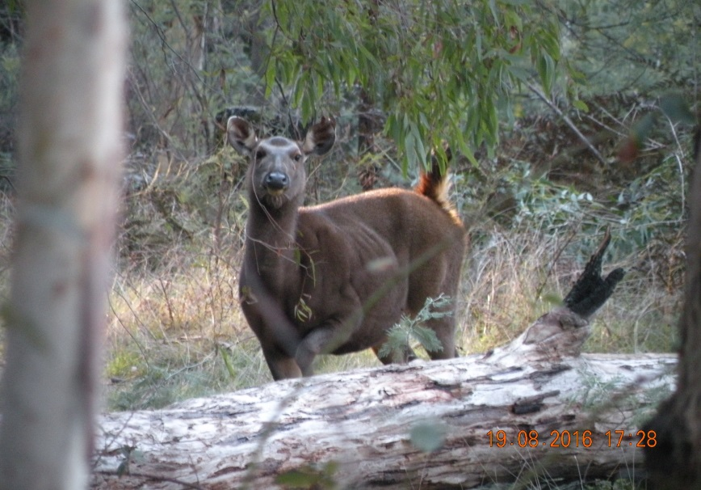

The ADA Victorian Hunter Education Course remains the most comprehensive Hunter Education Course in Australia and certainly gives great value for money.

It takes place from Friday the 4th of May (evening) until Sunday 6th of May. It is a very full on weekend and you will learn a huge amount of deer hunting information as well as a booklet of over 200 pages of information relating to deer hunting

Subjects at the Course include an “Introduction to the Deer” of Australia, “Deer Sign”, two sessions on deer stalking one by Rob Fickling from “Beyond the Divide” and “Moroka 30” and the other by Peter Burke who has over forty years of deer hunting experience and is now running his “Sambar Hunters Edge” Course.
Other subjects include the “Breakdown of the deer” in the bush, “butchering”, “Caping out” and caring for the trophy,
“Deer Hunting and the Law” by Stewart McGlashan from the GMA, “Deer Hunting Safety”, “Deer Hunting with a companion dog”. “Hound Hunting” and more.

There is also a three and half hour field trip in prime sambar country
in small groups guided by experienced hunters and with various “Stations” along the way where different aspects of deer behaviour are explained.

The Presenters from all the sessions are very experienced and more than happy to answer questions and impart their knowledge to you, amongst these are Peter Christian from “Bawbaw Adventures” and Paul Boag from ‘Paul Boags Outdoor Adventures” both of them are third generation hunters and very, very experienced.

The Course costs $399 for ADA members, $499 for non members and $299 for a junior although they must be accompanied by a fully paid up adult.
Bookings can be made on the ADA website austdeer.com.au.
Food and accommodation are provided.
Once your booking is made you will receive an information pack on the weekend in the mail.

